Project 2

Will Graham

# **Rapidly-Exploring Random Trees**

Env0 and Env 1 with 5% probability of sampling towards goal

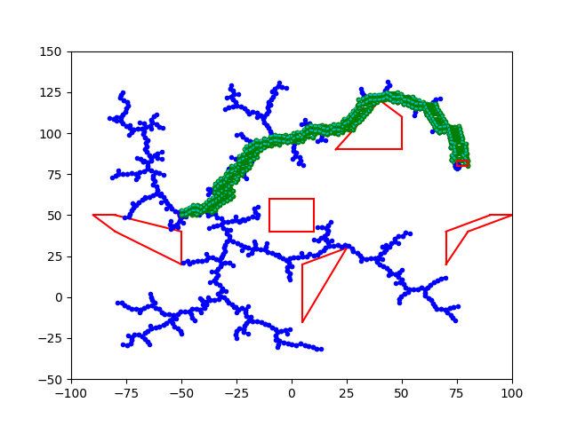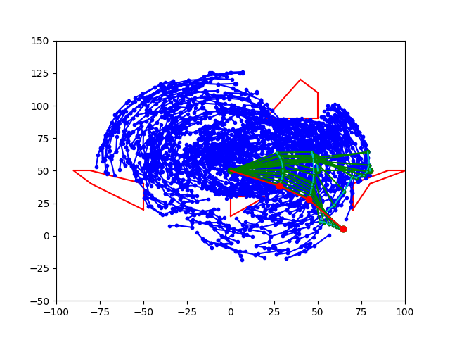

Env 0 and Env 1 with 10% probability of sampling towards goal